Beyond the Lean Start-Up:

Experimentation in Corporate Entrepreneurship and Innovation

Christian Hampel*

Markus Perkmann

Nelson Phillips

Imperial College Business School

South Kensington Campus

London SW7 2AZ

Essay for consideration for publication in Innovation: Management and Organization.

*The authors are listed in alphabetical order.

Beyond the Lean Start-Up:

Experimentation in Corporate Entrepreneurship and Innovation
In this essay, we argue that entrepreneurship and innovation researchers should pay more attention to experimentation as an approach to innovation and corporate entrepreneurship in established firms. While there is a growing body of research examining experimentation in start-ups, there is no corresponding literature investigating the role of experiments in the innovation and corporate entrepreneurship activities of established firms despite the increasing interest in experimentation among managers and the growing practitioner literature urging established firms to adopt experimentation. We discuss this trend and point to a number of research areas that we believe deserve systematic research.

Experiments are the basis on which modern science, and therefore in an important way modern society, has flourished. In a well-known early discussion of experiments and their role in science, Sir Francis Bacon explained the then revolutionary idea in this way (Bacon, 1926):
There remains simple experience; which, if taken as it comes, is called accident, if sought for, experiment. The true method of experience first lights the candle [hypothesis], and then by means of the candle shows the way [arranges and delimits the experiment]; commencing as it does with experience duly ordered and digested, not bungling or erratic, and from it deducing axioms [theories], and from established axioms again new experiments.
In entrepreneurship, experimentation has become the basis for one of the most influential approaches to launching new ventures. The lean start-up approach (Blank and Dorf, 2012; Ries, 2011) involves turning the underlying assumptions upon which a business model is built into hypotheses that can be tested through the careful use of experiments in much the same way as Bacon described. The promise of experimentation as an approach is that business model development can proceed faster, with higher certainty and lower resource requirements. The idea of running experiments and then “pivoting” has become central to entrepreneurship practice on a global level and is commonly taught to entrepreneurs in incubators, business schools and co-working spaces as the most effective approach to launching a successful venture (Aulet, 2013; Eisenmann, Ries, & Dillard, 2011).
Recently, the ideas developed around lean entrepreneurship have been taken up by large firms, with the promise that this approach can benefit corporate innovation and corporate venturing processes by accelerating them, reducing resource expenditure, and increasing the chances of success (Humble, Molesky, & O'Reilly, 2014; Owens and Fernandez, 2014; Ries, 2017; Ries and Euchner, 2013). By following Bacon’s simple process of turning the assumptions underlying our innovative idea into hypotheses, testing them, and adjusting our idea accordingly, corporate innovation can, it is argued, be revolutionized (Thomke and Manzi, 2014).
This is not, of course, a completely new direction for innovation. For example, Peter Drucker, in Innovation and Entrepreneurship, called for managers to act like scientists, and systematically and dispassionately analyse empirical evidence to detect threats and identify opportunities for new products and services (Drucker, 1985). Drucker championed the importance of listening attentively to the customer, targeting specific segments and deploying metrics for measuring success. Yet, by explicitly introducing experimentation, the modern lean approach to innovation has taken a step further in operationalizing the scientific method for product ideation and development.
At the same time, we find it surprising that, while there is a growing body of research on experimentation in start-ups (Contigiani, 2018; Contigiani and Levinthal; Gambardella, Camuffo, Cordova, & Spina, 2018), researchers have yet to turn to exploring how experimentation is conducted in established firms and used as a tool to support corporate innovation and corporate venturing. We will take up this cause and argue that researchers in innovation and entrepreneurship have an exciting opportunity to systematise and scrutinise the growing trend to experiment in established organizations. While corporate experimentation may share features with the practices deployed in start-ups, there are sufficient differences between the two types of firms to warrant separate attention to experimentation in large firms.

Key Characteristics of Experimentation
Experimentation can be seen as a systematic way for entrepreneurial innovators to learn about market opportunities and how they may exploit them. Rather than traditional market research and careful planning from the outset, the innovator proceeds by iteratively experimenting within their environment (Gans, Stern, & Wu, 2019). Experimentation as an approach to product innovation represents a specific way in which a firm goes about its search for optimal or satisfactory innovations (Baumann, Schmidt, & Stieglitz, 2019; Gans, et al., 2019). An iterative process based on tentative customer response replaces other, more traditional methods of determining product development choices, including stage-gate approaches, technology-driven development, imitation tactics or simply less systematic approaches to determining market response.
As a specific approach to the innovation process, experimentation has the following distinct features. First, the approach is based on matching the supply of ideas and capabilities with the likely demand by customers. An acceptable “product-market fit” is reached when an appropriate and defensible idea or product concept is matched with the needs or problems experienced by a specific group of customers. During this process of customer discovery (Blank and Dorf, 2012), both the product concept as well as the prospective target customer segments are seen as tentative and open to revision, until a satisfactory match is found.
Second, the product development process is driven by hypotheses about customer needs and customer adoption (and not the technical features of a solution). In this scientific approach to entrepreneurial decision-making (Gambardella, et al., 2018), hypotheses are formulated for all conditions deemed necessary or sufficient for customer acceptance, yet affected by high uncertainty in this respect. This approach allows a product development team or an entrepreneur to logically decompose a general idea into all of those conditions that need to be fulfilled in order to make a product successful. For example, these conditions may be linked to specific features of potential customers, time and circumstances of consumption, or the way in which customers can access a product or service.
Third, the process is conducted sequentially. The innovator identifies the most critical hypotheses first, with additional attention paid to the cost of conducting an experiment (Eisenmann, et al., 2011). In ideal terms, this process virtualises product development because product features are developed in concept only and tested by requesting feedback from the environment. This process has the purpose of minimising the resources required for actual, physical product development or development of fully-fledged prototypes.
A corporate innovation process based on experimentation can be summarized in the following steps (see Figure 1). First, the corporate innovator develops a preliminary product theory that explains the key dimensions of the product and the reason why specific customers need it. The next step involves decomposing that product theory into specific, testable hypotheses. This is followed by conducting experiments that determine whether or not each of the hypotheses can be validated “by means of the candle shows the way [arranges and delimits the experiment]” (Bacon, 1926). Experiments require careful construction to make sure that they test the hypothesis in question: “commencing as it does with experience duly ordered and digested, not bungling or erratic” (Bacon, 1926). Then, based on the results of the experiments, the underlying theory may need to be adjusted and the whole process repeated: “and from it deducing axioms [theories], and from established axioms again new experiments” (Bacon, 1926). This process continues until the key hypotheses are validated, thus leading to the emergence of a validated product theory. Once this occurs, the corporate innovator has successfully deployed experimentation to develop a new product for which there is demonstrable customer demand.
---------------------------------------------
INSERT FIGURE 1 AROUND HERE
---------------------------------------------

Organized Experimentation in Established Firms
Traditionally, established firms, particularly large ones, have primarily pursued Research & Development (R&D) in specialised R&D units to run (internal) technical experiments on its technology, rather than developing this technology (externally) with its customers. The classic R&D approach, institutionalised in the first part of the 20th century, is carried out by professionalised scientific and technological staff (Mowery, 2009). These are functionaly segregated from customer-facing functions, such as sales and marketing. This increases the risk that corporations create products ill-suited for customer preferences.
The lean start-up approach has inspired a plethora of new innovation tools by which established firms can get access to new ideas and use experimentation to test these externally among customers. A first key type is one-off events for exploring new ideas and accelerating their development, such as jams, hackathons and start-up camps (Fecher, Winding, Hutter, & Füller, 2018). For example, hackathons task participants – who are often external to the firm – with rapidly developing early-stage ideas that address a specific innovation goal in a limited time (Flores et al., 2018; Granados and Pareja-Eastaway, 2019; Pe-Than et al., 2019). Developing approaches for testing these ideas through experimentation is often a key aspect of these one-off events.
Permanent facilities for incubating ideas, such as innovation labs or accelerators, are a second key innovation tool that integrates external experimentation into corporate R&D. Both are physical spaces that offer a structured process for developing and testing early-stage ideas in a rapid, time-limited fashion (Kohler, 2016; Lewis and Moultrie, 2005; Magadley and Birdi, 2009). According to Capgemini, 87% of large firms have established an innovation centre or lab, understood as a facility aimed at convening multidisciplinary teams for focused innovation projects, usually drawing on the lean approach (Capgemini, 2017). Innovation labs often draw on the firm’s employees to develop ideas and rely on the corporation’s existing business units for developing promising ideas. In turn, corporate accelerators primarily select and support external entrepreneurial teams in pursuing their ideas in a standalone fashion, if the structured customer discovery and experimentation suggests product-market fit, and thus a promising opportunity (Cohen, Bingham, & Hallen, 2018; Shankar and Shepherd, 2018).
Overall, existing work has started to explore the organizational devices that established firms use to implement lean, experimentation-based approaches to corporate innovation. However, this research has left two blind spots: first, it has focused on specific time-limited programs that serve as add-ons to corporate innovation and venturing that continues in its classic fashion, rather than exploring how to integrate experimentation more holistically in core R&D departments and across the innovation and venturing process. Second, and relatedly, little attention has so far been paid to the study of corporate experimentation as a unit of analysis in its own right. Against the background of the amount of practitioner attention that this approach has garnered, we believe that there are numerous research opportunities for management scholars which we outline below.

Research Opportunities
Scholarship on experimentation in entrepreneurship is limited to a handful of publications to date. These suggest that adopting a systematic experimental approach is superior to less systematic approaches to developing entrepreneurial solutions (Gambardella, et al., 2018) and is particularly useful in contexts where ideas can be protected as otherwise early experiments may provide clues to imitators, eroding a focal innovator’s competitive advantage (Contigiani, 2018).
At the same time, much remains to be systematically examined about experimentation in established firms and in this section we will outline some of the areas that we think are of particular importance. We will organize our discussion of research opportunities using three key questions. First, what are the conditions under which experimentation can be successfully initiated and carried out in established firms? Second, what are the characteristics of those experimentation practices and processes that lead to effective experimentation? And third, what are the outcomes of experimentation in established firms? (see Table 1 for overview).
---------------------------------------------
INSERT TABLE 1 AROUND HERE
---------------------------------------------

Antecedents to Experimentation in Established Firms
Exploring the antecedents to experimentation represents the first fruitful area for future research. One of the foremost questions in this respect is what types of products and what types of sectors are most amenable to experimentation. Historically, the lean method – with experimentation at its centre – is closely associated with the “tech” sector. Software solutions, both self-standing or part of Internet-based services, can be programmed and modified relatively quickly, and access to potential customers is rapid and cost-efficient. Therefore, in this product space, experimentation can be fine-grained and proceed relatively quickly. Another sector where experimentation is frequently practiced is retail services (Thomke and Manzi, 2014). In this sector, large operators can take advantage of the fact that they run thousands of largely similar outlets allowing them to test customer acceptance on a step-by-step basis in part of their portfolio. Given this focus on specific sectors, the question remains as to what degree experimentation is generalizable to other sectors where product development is more lengthy, requires much larger investment, the sales process is less standardized, slower and more complex, and customers are not as easily reachable for providing feedback on successive experimental steps.
Experimentation also raises important questions about organizational design. Scholars have discussed the benefits of integration and differentiation particularly with respect to the innovation function (Lawrence and Lorsch, 1967; O’Reilly III and Tushman, 2016). A widespread adoption of experimentation within established firms requires a closer integration between the innovation and the customer-facing functions than previously was the norm. Alternatively, a firm may choose to build customer-facing teams and job profiles within an existing innovation function. Yet another option may be to establish new units specializing in experimentation, possibly at the interface with the existing innovation and innovation functions. As each of these alternatives will result in different outcomes, it is important for researchers to study the various organizational designs that facilitate building experimentation into the innovation process. This can be broken down into sub-questions which are core to organizational design (Puranam, 2017), i.e. how best to institute experimentation as a distinct, specialised competence, and how to integrate the resulting efforts with existing activities to achieve favourable innovation outcomes.
Finally, one may speculate that organizations differ with respect to their cognitive openness towards experimentation practices. The literature on innovation has frequently referred to organization-wide cognitive structures that lock companies into specific paradigms and prevent “break out” innovation (Porac, Thomas, & Baden-Fuller, 1989; Tripsas and Gavetti, 2000). This raises the question of whether some organizations – by virtue of cognitive structures such as their organizational identity – are more “experimentation ready” than others. O’Reilly and Tushman (2016), for instance, cite the Ball Corporation as a company whose organizational identity was broad and flexible enough to innovate across entirely different product categories. So one may surmise that such organizations would be more amenable to experimentation and also be able to abide by the results of experiments (Thomke and Manzi, 2014), compared to those locked into narrow, rigid business models (Tripsas and Gavetti, 2000).
In sum, with respect to antecedents to experimentation, it would be valuable to explore the types of sectors and product spaces that are most amenable to effective experimentation, as well as the organizational designs and cognitive preconditions that facilitate it.

Experimentation Practices and Process
Apart from establishing when experimentation is feasible and possible, it is important to determine how established firms can employ experimentation effectively for innovation by identifying suitable practices and processes for doing so.
A first area for research concerns the design and implementation of experimentation. While the practitioner literature has proposed a series of prescriptions, for both start-ups and established organizations, there has been little research on and validation of specific approaches and techniques. For instance, what formal methods can be used for prioritizing which hypotheses should be tested first? Who, within an established firm, should be involved in the design and interpretation of experimentation results? How should the quality thresholds be determined for when results are considered reliable? Answers to these and related questions are crucial for informing robust practice in experimentation.
In addition to exploring the specifics of how to conduct experiments, research should also examine the contextual conditions under which experimentation can be successfully pursued. The widespread introduction of experimentation could potentially challenge traditional corporate-bureaucratic contexts with established structures of authority and resource allocation. In fact, practitioner-oriented thinkers believe that experimentation is only one element within a wider adoption of the entrepreneurial method within established firms (Ries, 2017). This has implications for how job roles are defined – everybody can potentially be an entrepreneur - how rewards are distributed, how resources are allocated and how projects are governed. From a scholarly perspective, it would be interesting to examine the implications, for instance, for employees’ identification with the firm. Furthermore, it is likely that there willl be common challenges where firms introduce new job functions or reconfigure the power relationships between different groups of employees (Carlile, 2002; Dougherty, 1992, 2017). In particular, experimentation may require technical or scientific personnel to attend to market derived constraints or instructions much earlier than in traditional innovation practice.

Experimentation Outcomes
What will be the outcomes of systematically practicing experimentation? A narrow interpretation of this question would ask whether experimentation will make established firms more innovative or improve the success chances of newly launched products or services. Evidence on the effectiveness of the experimentation approach is currently lacking and would be required to lend credibility to it as well as to identify boundary conditions. Empirically isolating experimentation from confounding factors and determining its causal effect on outcomes will be challenging, calling for research designs that in themselves may call for the conduct of experiments.
Yet apart from the direct effect of experimentation on key metrics of innovation performance, there are a variety of other, broader outcomes that future research may consider. Such second-order outcomes include the long-term direction of innovation and consequences for competitive strategy.
A first impact to consider is how experimentation may affect the direction of innovation. The use of experimentation may lead innovators to eschew grand visions in favour of a more incremental product development trajectory, and hence fail to bring truly disruptive ideas to market. One may argue that some products or product ideas are so visionary or speculative that experiments would risk delivering false negatives and curtailing continued investments in promising opportunities. For instance, to what degree would an experimental approach have led to the development of the iPhone, particularly as it was Steve Jobs who claimed that “A lot of times, people don't know what they want until you show it to them”?
In the wider picture, then, the experimentation approach needs to be scrutinised within the context of the long-standing conversation about the origins of innovation between technology push and market pull. Starting with Levitt’s (1960) “Marketing Myopia”, there is a long tradition of scholarship arguing that an excessive focus on customer needs may be detrimental to effective innovation (Christensen, 1997; Foster, 1988). However, the challenge for scholarship is not to adjudicate on the merits of market focus, as it is clear today that even the development of disruptive innovations will benefit from customer focus if targeted at the correct segment of consumers or non-consumers. Hence, researchers should examine the circumstances under which experimentation may overcome “myopia” and local search. This should include questions pertaining to the selections of customer groups and the factors biasing corporate innovations towards privileging certain groups and the relationship between customer-focused experiments and existing products. Methodologically, as negative outcomes are difficult to research, scholars may screen historic cases for evidence of experimentation and also create theoretical models to simulate the process by which experimentation may lead to truly innovative products.
Another broader impact of experimentation relates to consequences for a firm’s competitive strategy. As Contigiani (2018) has pointed out, experimentation often involves the need to disclose information about one’s innovation to the external environment, exposing the firm to the threat of imitation. It would be important to explore to what extent the disclosure of information due to experimentation influences the quantity and quality of imitation by competitors.
Another consideration is whether early experimentation will threaten to cannibalise a firm’s existing product line-up as customers may be building up expectations for future product releases and wait with their purchase (Bhaskaran, Erzurumlu, & Ramachandran, 2018). On the other hand, early visibility of potential future products may attract stakeholders, such as future complementors, to an experimenting firm – constituting in fact a form of openness as the firm decides to selectively reveal knowledge assets (Alexy, George, & Salter, 2013). Virtually all of these possible strategic implications of experimentation, and possibly many others, remain unexplored.
In sum, as we have discussed in this section has shown, uncovering the impact of experimentation on innovation and competitive strategy outcomes offers much promise and deserves the attention of scholars.

Conclusions
Our intention in writing this essay was to highlight the important research opportunities that exist around the use of experiments as a tool for innovation and corporate entrepreneurship in established firms. While experimentation is becoming increasingly popular in firms to explore assumptions underpinning innovations and to gain customer insight, we have little systematic evidence about the sorts of challenges that firms face in using experimentation in innovation, tactics for getting around these challenges, and the limits of application of experimentation in established firms.
We have outlined a series of areas that provide promising hunting grounds for management scholars for interesting in developing research questions to investigate this important development in managerial practice. As we are writing this in the very early stages of the research cycle on a phenomenon, we believe there is scope for both qualitative and quantitative work, as well as theory-driven work including simulations, across a range of theoretical conversations ranging from strategy, to corporate entrepreneurship, organization theory and organizational behaviour.

APPENDIX
Table 1: Overview of Opportunities for Future Research

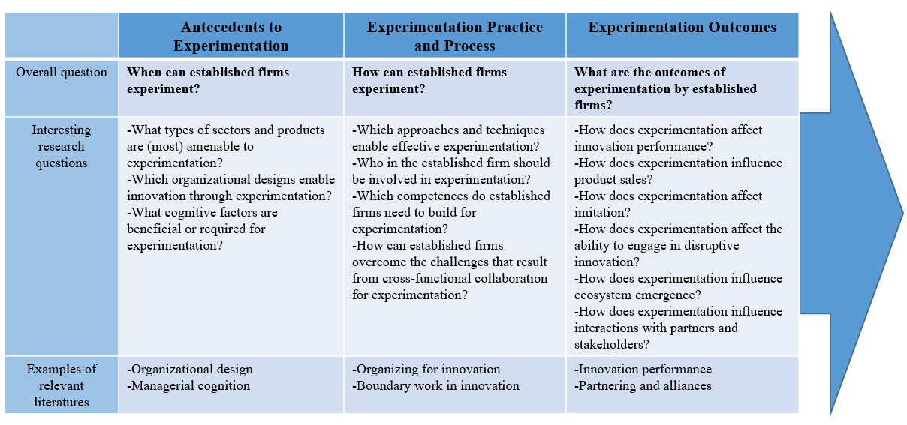

Figure 1: Experimentation Process in Corporate Innovation and Entrepreneurship

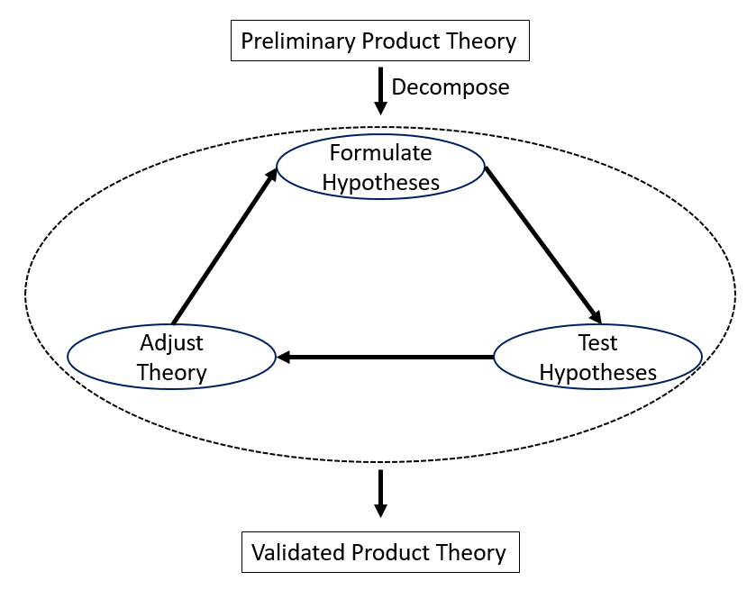

BIBLIOGRAPHY
Alexy, O., George, G., & Salter, A. J. (2013). Cui bono? The selective revealing of knowledge and its implications for innovative activity. Academy of Management Review, 38(2), pp. 270-291.
Aulet, B. (2013). Disciplined entrepreneurship: 24 steps to a successful startup: John Wiley & Sons.
Bacon, F. (1926). Novum Organum. In W. Durant (Ed.), The story of philosophy: Simon & Schuster.
Baumann, O., Schmidt, J., & Stieglitz, N. (2019). Effective Search in Rugged Performance Landscapes: A Review and Outlook. Journal of Management, 45(1), pp. 285-318.
Bhaskaran, S. R., Erzurumlu, S., & Ramachandran, K. (2018). Sequential Product Development and Introduction by Cash-Constrained Start-Ups. Georgia Tech Scheller College of Business Research Paper(18-39), pp. 18-34.
Blank, S., & Dorf, B. (2012). The startup owner's manual: The step-by-step guide for building a great company: BookBaby.
Capgemini. (2017). The discipline of innovation – Making sure your innovation center actually makes your organization more innovative. Paris
Carlile, P. R. (2002). A pragmatic view of knowledge and boundaries: boundary objects in new product development. Organization Science, 13(4), pp. 442-455.
Christensen, C. M. (1997). The innovator's dilemma: when new technologies cause great firms to fail Boston, Mass: Harvard Business School Press.
Cohen, S. L., Bingham, C. B., & Hallen, B. L. (in press). The Role of Accelerator Designs in Mitigating Bounded Rationality in New Ventures. Administrative Science Quarterly.
Contigiani, A. (2018). Experimentation, Learning, and Appropriability in Early-Stage Ventures. Available at SSRN ( http://dx.doi.org/10.2139/ssrn.3282261).
Contigiani, A., & Levinthal, D. A (in press). Situating the construct of lean start-up: adjacent conversations and possible future directions. Industrial and Corporate Change.
Dougherty, D. (1992). Interpretive barriers to successful product innovation in large firms. Organization Science, 3(2), pp. 179-202.
Dougherty, D. (2017). Organizing for innovation in complex innovation systems. Innovation: Organization & Management, 19(1), pp. 11-15.
Drucker, P. F. (1985). Innovation and entrepreneurship Oxford: Elsevier.
Eisenmann, T., Ries, E., & Dillard, S. (2011). Hypothesis-Driven Entrepreneurship: The Lean Startup. Harvard Business School Background Note 812-095, December 2011 (Revised July 2013.) Cambridge MA
Fecher, F., Winding, J., Hutter, K., & Füller, J. (in press). Innovation labs from a participants' perspective. Journal of Business Research
Flores, M., Golob, M., Maklin, D., Herrera, M., Tucci, C., Al-Ashaab, A., . . . Zaki, M. (2018). How can hackathons accelerate corporate innovation? IFIP International Conference on Advances in Production Management Systems.
Foster, R. N. (1988). Innovation: The attacker's advantage: Summit books.
Gambardella, A., Camuffo, A., Cordova, A., & Spina, C. (in press). A Scientific Approach to Entrepreneurial Decision Making: Evidence Form a Randomized Control Trial. Management Science.
Gans, J. S., Stern, S., & Wu, J. (2019). Foundations of entrepreneurial strategy. Strategic Management Journal, 40(5), pp. 736-756.
Granados, C., & Pareja-Eastaway, M. (in press). How do collaborative practices contribute to innovation in large organisations? The case of hackathons. Innovation: Organization & Management, pp. 1-19.
Humble, J., Molesky, J., & O'Reilly, B. (2014). Lean enterprise: How high performance organizations innovate at scale Sebastopol CA: O'Reilly Media.
Kohler, T. (2016). Corporate accelerators: Building bridges between corporations and startups. Business Horizons, 59(3), pp. 347-357.
Lawrence, P. R., & Lorsch, J. W. (1967). Differentiation and integration in complex organizations. Administrative Science Quarterly, 12(1), pp. 1-30.
Levitt, T. (1960). Marketing myopia. Harvard Business Review, 38(4), pp. 24-47.
Lewis, M., & Moultrie, J. (2005). The organizational innovation laboratory. Creativity and Innovation Management, 14(1), pp. 73-83.
Magadley, W., & Birdi, K. (2009). Innovation labs: an examination into the use of physical spaces to enhance organizational creativity. Creativity and Innovation Management, 18(4), pp. 315-325.
Mowery, D. C. (2009). Plus ca change: Industrial R&D in the "third industrial revolution". Industrial and Corporate Change, 18(1), pp. 1-50.
O’Reilly III, C. A., & Tushman, M. L. (2016). Lead and disrupt: How to solve the innovator's dilemma: Stanford University Press.
Owens, T., & Fernandez, O. (2014). The lean enterprise: How corporations can innovate like startups Hoboken NJ: Wiley.
Pe-Than, E. P. P., Nolte, A., Filippova, A., Bird, C., Scallen, S., & Herbsleb, J. D. (2019). Designing Corporate Hackathons With a Purpose: The Future of Software Development. IEEE Software, 36(1), pp. 15-22.
Porac, J. F., Thomas, H., & Baden-Fuller, C. (1989). Competitive groups as cognitive communities: the case of Scottish knitwear manufacturers. Journal of Management Studies, 26(4), pp. 397-416.
Puranam, P. (2017). When will we stop studying innovations in organizing, and start creating them? Innovation: Organization & Management, 19(1), pp. 5-10.
Ries, E. (2011). The lean startup: How today's entrepreneurs use continuous innovation to create radically successful businesses: Crown Books.
Ries, E. (2017). The Startup Way: How Modern Companies Use Entrepreneurial Management to Transform Culture and Drive Long-term Growth: Currency.
Ries, E., & Euchner, J. (2013). What large companies can learn from start-ups. Research-Technology Management, 56(4), pp. 12-16.
Shankar, R. K., & Shepherd, D. A. (in press). Accelerating strategic fit or venture emergence: Different paths adopted by corporate accelerators. Journal of Business Venturing.
Thomke, S., & Manzi, J. (2014). The Discipline of Business Experimentation. Harvard Business Review, 92(12), pp. 70-79.
Tripsas, M., & Gavetti, G. (2000). Capabilities, cognition, and inertia: evidence from digital imaging. Strategic Management Journal, 21(10-11), pp. 1147-1161.

